- Praktikum 1
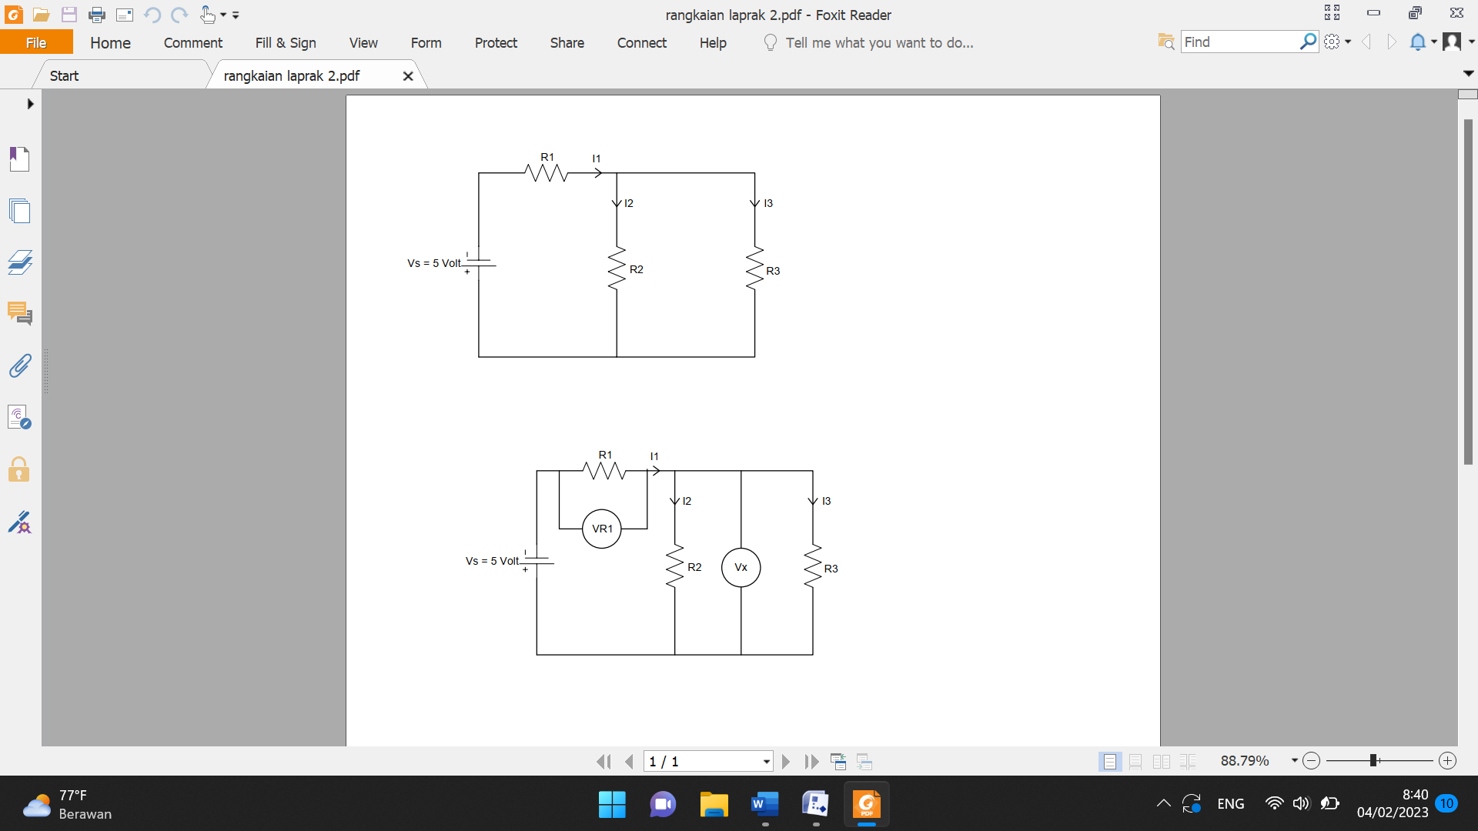
No | Resistor (Ω) |  |  | Teori (mA) |  |  |  | Hasil Pengukuran (mA)
No | R₁ | R₂ | R₃ | I1 | I2 | I3 | I2+I3 | I1 | I2 | I3 | I2+I3
1 | 220 | 330 | 150 | 15,47 | 4,83 | 10,63 | 15,46 | 15,34 | 4,81 | 10,54 | 15,35
2 | 150 | 220 | 330 | 17,7 | 10,62 | 7,08 | 17,7 | 17,48 | 10,60 | 7,07 | 17,67
3 | 2,2K | 1K | 5,6K | 1,64 | 1,39 | 0,24 | 1,63 | 1,68 | 1,40 | 0,25 | 1,65
4 | 1K | 2,2K | 5,6K | 1,938 | 1,391 | 0,546 | 1,937 | 1,94 | 1,39 | 0,54 | 1,93

$$I_{1}= \frac{V}{R}=\frac{V_{s}}{R_{1}+(R_{2}//R_{3})}= \frac{5}{220+(330//150)}=15,47 mA$$
$$I_{2}= \frac{R_{3}}{R_{2}+R_{3}}×I_{1}= \frac{150}{330+150}×15,47 mA=4,83 mA$$
$$I_{3}= \frac{R_{2}}{R_{2}+R_{3}}×I_{1}= \frac{330}{330+150}×15,47 mA=10,63 mA$$
$$I_{2}+I_{3}=4,83 mA+10,63 mA=15,46 mA$$

$$I_{1}= \frac{V}{R}=\frac{V_{s}}{R_{1}+(R_{2}//R_{3})}= \frac{5}{150+(220//330)}=17,7 mA$$
$$I_{2}= \frac{R_{3}}{R_{2}+R_{3}}×I_{1}= \frac{330}{220+330}×17,7 mA=10,62 mA$$
$$I_{3}= \frac{R_{2}}{R_{2}+R_{3}}×I_{1}= \frac{220}{220+330}×17,7 mA=7,08 mA$$
$$I_{2}+I_{3}=10,62 mA+7,08 mA=17,7 mA$$

$$I_{1}= \frac{V}{R}=\frac{V_{s}}{R_{1}+(R_{2}//R_{3})}= \frac{5}{2,2K+(1K//5,6K)}=1,64 mA$$
$$I_{2}= \frac{R_{3}}{R_{2}+R_{3}}×I_{1}= \frac{5,6K}{1K+5,6K}×1,64 mA=1,39 mA$$
$$I_{3}= \frac{R_{2}}{R_{2}+R_{3}}×I_{1}= \frac{1K}{1K+5,6K}×1,64 mA=0,24 mA$$
$$I_{2}+I_{3}=1,39 mA+0, 24 mA=1,63 mA$$

$$I_{1}= \frac{V}{R}=\frac{V_{s}}{R_{1}+(R_{2}//R_{3})}= \frac{5}{1K+(2,2K//5,6K)}=1,938 mA$$
$$I_{2}= \frac{R_{3}}{R_{2}+R_{3}}×I_{1}= \frac{5,6K}{2,2K+5,6K}×1,938 mA=1,391 mA$$
$$I_{3}= \frac{R_{2}}{R_{2}+R_{3}}×I_{1}= \frac{2,2K}{2,2K+5,6K}×1,938 mA=0,546 mA$$
$$I_{2}+I_{3}=1,391 mA+0, 546 mA=1,937 mA$$
- Praktikum 2
No | Resistor (Ω) |  |  | Teori (V) |  |  | Hasil Pengukuran (V)
No | R₁ | R₂ | R₃ | VR1 | VX | VR1+VX | VR1 | VX | VR1+VX
1 | 220 | 330 | 150 | 3,404 | 1,5957 | 4,9997 | 3,332 | 1,592 | 4,924
2 | 150 | 220 | 330 | 2,659 | 2,340 | 4,999 | 2,614 | 2,302 | 4,916
3 | 2,2K | 1K | 5,6K | 3,608 | 1,391 | 4,999 | 2,643 | 1,391 | 5,043
4 | 1K | 2,2K | 5,6K | 1,938 | 3.061 | 4,999 | 1,934 | 3,064 | 4,998

$$V_{R1}=\frac{R_{1}}{R_{1}+(R_{2}//R_{3})}×V_{s}= \frac{220}{220+(330//150)}×5=3,404 Volt$$
$$V_{x}=\frac{R_{2}//R_{3}}{R_{1}+(R_{2}//R_{3})}×V_{s}=\frac{330//150}{220+(330//150)}×5= 1,595 Volt$$
$$V_{R1}+V_{x}=3,404 Volt+1,5957 Volt=4,999 Volt$$

$$V_{R1}=\frac{R_{1}}{R_{1}+(R_{2}//R_{3})}×V_{s}= \frac{150}{150+(220//330)}×5=2,659 Volt$$
$$V_{x}=\frac{R_{2}//R_{3}}{R_{1}+(R_{2}//R_{3})}×V_{s}=\frac{220//330}{150+(220//330)}×5= 2,340 Volt$$
$$V_{R1}+V_{x}=2,659 Volt+2,340 Volt=4,999 Volt$$

$$V_{R1}=\frac{R_{1}}{R_{1}+(R_{2}//R_{3})}×V_{s}= \frac{2,2K}{2,2K+(1K//5,6K)}×5=3,608 Volt$$
$$V_{x}=\frac{R_{2}//R_{3}}{R_{1}+(R_{2}//R_{3})}×V_{s}=\frac{1K//5,6K}{2,2K+(1K//5,6K)}×5= 1,391 Volt$$
$$V_{R1}+V_{x}=3,608 Volt+1,391 Volt=4,999 Volt$$

$$V_{R1}=\frac{R_{1}}{R_{1}+(R_{2}//R_{3})}×V_{s}= \frac{1K}{1K+(2,2K//5,6K)}×5=1,938 Volt$$
$$V_{x}=\frac{R_{2}//R_{3}}{R_{1}+(R_{2}//R_{3})}×V_{s}=\frac{2,2K//5,6K}{1K+(2,2K//5,6K)}×5= 3,061 Volt$$
$$V_{R1}+V_{x}=1,938 Volt+3,061 Volt=4,999 Volt$$

